Canarium (*Canarium indicum*) cake as a source of lysine in fermented cassava-copra meal diets with challenzyme for broilers

Sandakabatu, D. and Diarra, S.S.

**ABSTRACT**

In a 32-day experiment, the effect of feeding canarium cake replacing of lysine in fermented cassava-copra meal based diets with or without challenzyme enzyme on broiler performance was investigated. Six test diets based on cassava-copra meal were formulated to have similar nutrients content to the commercial feed at starter and finisher phases. Two of the test diets were supplemented with HCL lysine with and without enzyme. In the other four diets canarium cake was fed at 5 and 10% with and without enzyme replacing of HCL lysine. A total of 126, 10-day old, broilers were allotted to 21 floor pens containing 6 birds each and groups of seven diets. The test diets and commercial diet (control) were fed each to birds in 3 replicate pens in a completely randomised design. Feed intake, weight gain, feed: gain, relative weights of carcass and breast muscle were improved on the commercial feed (P<0.05). There were no significant differences in growth and relative weights of carcass and breast muscle among the cassava-copra meal based diets (P>0.05). The relative weight of thighs did not differ among dietary treatments (P>0.05). Drumstick weight was maximised on the canarium diets without enzyme compared to the control (P<0.05). It was concluded cassava-copra meal based diets cannot produce performances comparable to the commercial diet regardless of nutrient balance and enzyme supplementation but canarium cake can replace HCL lysine in the diets without compromising growth and carcass parameters. Further researches into pelleting, enzyme source and concentration are recommended.

**KEY WORDS:** Alternative lysine sources**,** Canarium cake, Dietary fibre, Complex enzyme, Broiler performance

**INTRODUCTION**

High cost of conventional feed ingredients has increased research interest in alternative and affordable sources for poultry feeding. Cassava root is a good source of metabolisable energy (Fetuga and Oluyemi, 1976; Khajarern *et al.,* 1982) which could be used to replace part of the maize in poultry diets but high fibre, low protein and presence of HCN limit its full utilisation in poultry diets (Ochetim, 1992; Buitrago and Luckett, 1999; Chauynarong *et al.,* 2009; Anaeto and Adighibe, 2011; Heuzé *et al*., 2016b). Adequate processing reduces HCN below toxic levels for animal feeding (10mg/kg) (FAO/WHO, 2013). Fermentation is known to improve protein and reduce fibre contents in the root (Boonnop *et al.,* 2009; Ezekiel *et al.,* 2010; Nebiyu and Getachew**,** 2011; Gunawan *et al.,* 2015; Yuli *et al.,* 2015).

Copra meal is abundantly available in the Pacific islands. It is moderate in protein (19.6-24.9%), but deficient in essential amino acids, especially lysine (Heuzé *et al.,* 2015). The meal is high in fibre (10-19.7%) with most of the fibre being in the form of non-starch polysaccharides (NPS) (Heuzé *et al.,* 2015; Devi and Diarra, 2017) which impedes feed utilisation by poultry. The utilisation of copra meal by poultry could be improved with appropriate feed formulation, enzyme and amino acid supplementation (Sundu *et al.,* 2009; Sundu and Dingle, 2011; Devi and Diarra, 2017).

Canarium (*Canarium indicum*) is a tropical tree of the family *Burseraceae* which grows in the wild or domesticated in the Melanesian countries of the South Pacific (Nevenimo *et al.,* 2007; Djarkasi *et al.*, 2017). Canarium kernel is an average source of protein (about 15%) and lysine (1.9-2.7%) (Djarkasi *et al.,* 2011) which might increase with oil extraction. The kernel is high in oil and the oil is a good source of polyunsaturated fatty acids (Nevernimo *et al.,* 2007; Djarkasi *et al.,* 2007; Ogbuagu and Chukuka, 2015). In recent years there has been growing demand for canarium oil on account of its several medicinal properties making the meal available for stock feeding. However, reports on the application of canarium meal in broiler feeding are still limited. The potential of canarium meal as source of dietary lysine in fermented cassava-copra meal based diets with exogenous enzyme for broilers was investigated. Hypothesis:

1. Broilers will utilise fermented cassava-copra meal with enzyme better;
2. Canarium meal can replace HCL methionine in cassava-copra meal based broiler diets.

**MATERIALS AND METHODS**

**Study area**

The study was conducted at Lunga area (Latitude = 09.42687˚ S and Longitude = 160.03125˚ E), approximately 7 km east of Honiara. The location is of tropical climate with average temperature of 27°C, and 83% humidity that changes very little all year around (Tomahawk, 2018).

**Fermentation of cassava root**

*Saccharomyces cerevisiae* (yeast) was cultured in a sterilised cylinder vessel containing 20% sucrose (w/v), 4% urea (w/v) and 10 g yeast extract/l and incubated at room temperature for 60 hours (Boonnop *et al.*, 2009) prior to inoculation. Cassava roots from a seven-month old sweet variety was purchased from local cassava growers in the study area and thoroughly washed under tap water. Cassava roots with peel were sliced and loaded in a large fermentation vessel (200 ℓ capacity) at 50% (w/v) with 12.5% inoculum. About 37.5% water was added to keep the roots submerged. The vessel was then covered with loosen lid to allow dispersion of carbon dioxide during subsequent 60 hours of fermentation. After fermentation, the whole cassava root was pound and subjected to 3-4 days sun-drying. It was then stored in well shielded containers at room temperature until needed for diet formulation. Samples of fermented cassava root, copra, fish and canarium meals were analysed for proximate composition and amino acid profile. Fermented cassava root was also analysed for cyanide content (Table 1).

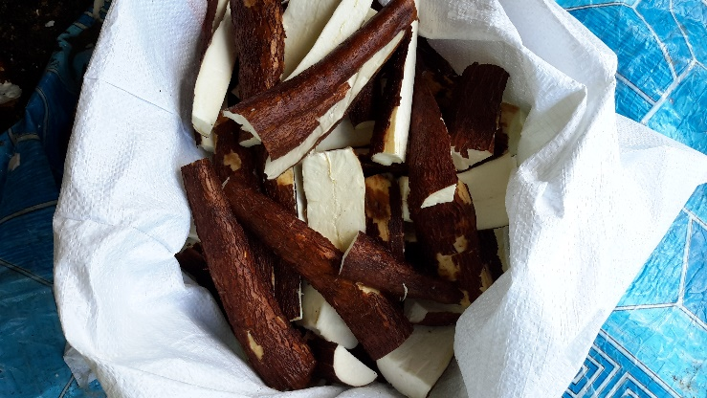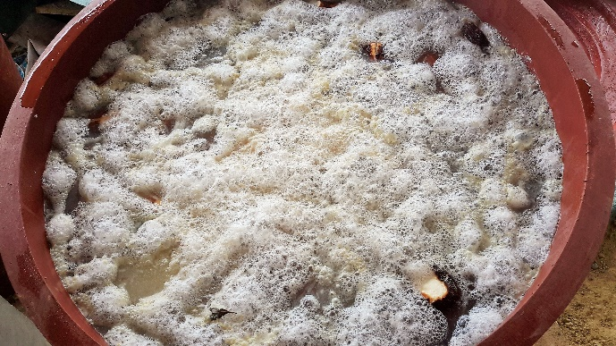

**Figure 1: Sliced cassava roots Figure 2: Cassava root fermentation**

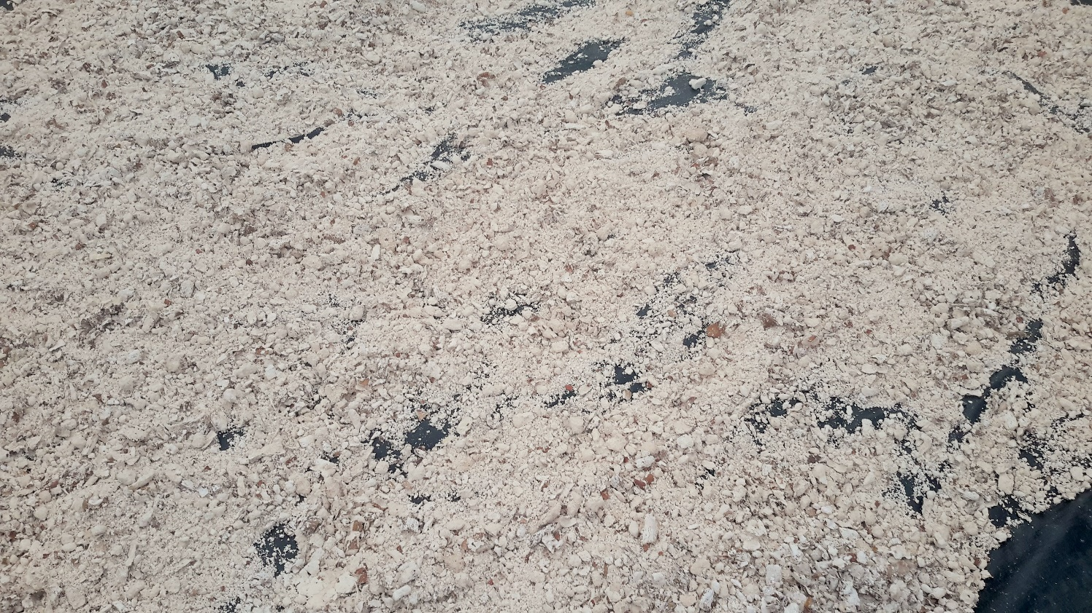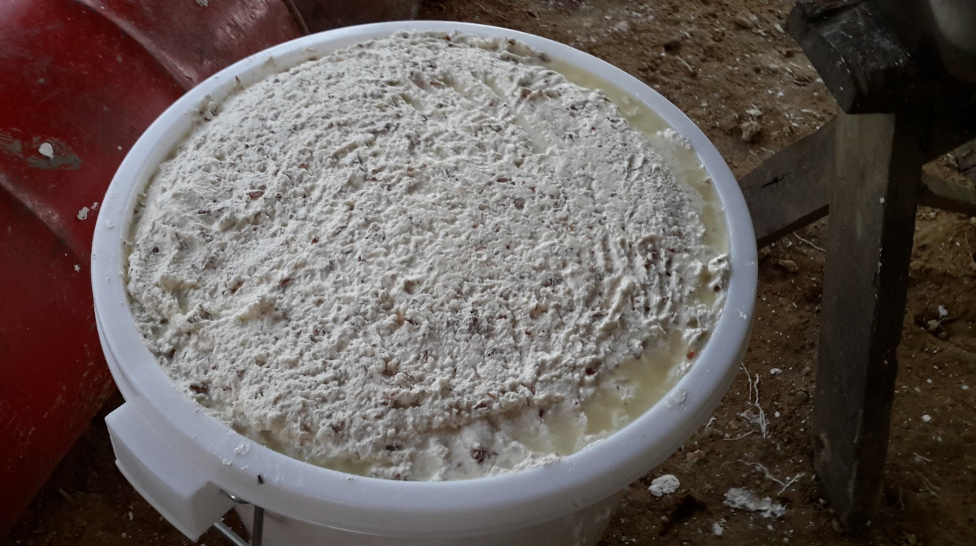

**Figure 3: Pounded cassava root meal Figure 4: Sun-dried cassava root meal**

**Experimental diets**

Six experimental diets based on fermented cassava and copra meal were formulated at starter and finisher phases (Table 2) to have similar ME, crude protein, lysine and methionine contents to the commercial broiler feed (control) from Riverina. Two of the experimental diets were formulated to contain HCL lysine. Canarium meal was included in the other diets in place of HCL lysine at 5 and 10%. The experimental diets were supplemented with or without challenzyme 1309A, a complex enzyme from Beijing Challenge Bio-Technology Co. Ltd. China.

**Experimental birds and managements**

In total, 126, 10-day old, Cobb broiler chicks were weighed and assigned to 21 floor pens (1 x 1.5 m) of similar weights (273 ± 15 g). Each of the diets was fed to 3 replicate pens in a completely randomised design from 10 d to 42 d. The starter diet was fed from day 10-21 d and the finisher diets from 22-42 d. The lighting programme consisted of 20 hours light. Feed and clean drinking water were provided *ad-libitum* throughout the duration of the experiment.

Table 1. Proximate composition (g/kg DM), amino acid content (g/100 g protein) and metabolisable energy (MJ/kg)

of canarium cake, fermented whole cassava root meal, copra and fishmeal

|  |  |  |  |  |
| --- | --- | --- | --- | --- |
| **Constituents** | **Canarium meal** | **Copra meal** | **Fish meal** | **Fermented cassava** |
| Crude Protein | 296 | 18.20 | 578 | 18 |
| Crude fibre | 112 | 118 | <1 | 21 |
| Crude fat | 436 | 115 | 160 | 4 |
| Ash | 74 | 50 | 206 | 11 |
| HCN (mg/kg) | NT | NT | NT | <0.0005 |
| ME (MJ/kg) | 20.5 | 12.8 | 13.85 | 11.97 |
| Histidine | 0.64 | 0.32 | 1.80 | 0.03 |
| Arginine | 1.20 | 0.70 | 2.50 | 0.06 |
| Threonine | 1.10 | 0.58 | 3.00 | 0.06 |
| Valine | 1.90 | 0.98 | 3.50 | 0.08 |
| Lysine | 2.95 | 0.60 | 4.70 | 0.09 |
| Isoleucine | 1.20 | 0.57 | 2.60 | 0.06 |
| Leucine | 2.40 | 1.20 | 5.10 | 0.10 |
| Phenylalanine | 1.60 | 0.73 | 2.60 | 0.06 |
| Methionine | 0.71 | 0.27 | 1.70 | 0.01 |
| Tryptophan | 0.45 | 0.14 | 0.55 | 0.02 |

NT: not tested.

**Data collection**

Weighed quantities of feed were fed and leftover weighed to account for feed-intake by difference. Weight gain was monitored by weekly weighing and feed conversion ratio calculated by dividing the feed intake by the weight gain in each pen. At the end of the experiment, two birds having the closest weight to the pen mean were selected and fasted overnight and euthanised by decapitation. Slaughtered birds were scaled in hot water (55oC) for 2 minutes, plucked and eviscerated. The weight of carcass and cuts (breast, thigh and drumsticks) were expressed as relative weights of the live chicken. Abdominal fats and organs (caeca, small intestine, pancreas, liver, gizzard, and heart) were also weighed and expressed as relative weights.

**Chemical analysis**

The test ingredients and fish meal were analysed for proximate composition according to AOAC (1990). Dry matter was determined after 24 h in a forced-air oven (103o C). Nitrogen concentration was analysed by Kjeldahl method (AOAC 1990, ID 954.01) and CP was calculated as nitrogen · 6.25. Total fat, ash and fibre contents were analysed according to AOAC (1990, ID 42.05, 920.39 and 962.09 respectively). Amino acid profile was determined using the Standard AAA hydrochloric acid hydrolysis followed by RP-HPLC separation using AccQ-Tag derivatisation (AOAC 1990, ID 994.12). The cyanide content of the UCRM was determined according to Zitnak ([1973](https://www.sciencedirect.com/science/article/pii/S1871141309003230" \l "bib32)).

**Statistical Analysis**

Data collected on growth, carcass measurements and organs weights were subjected to one-way analysis of variance (ANOVA) (Steel and Torrie, 1980) of the GLM in SPSS (SPSS for Windows, version 22.0; IBM Crop., Armonk, NY, USA). Pen was the experimental unit for feed intake while data on weight gain, carcass and organ measurements were collected on individual birds. Treatments means were compared using LSD and significant differences reported as 5% level of probability.

**Table 2. Ingredient composition of experimental starter diets (g/kg as fed)**

|  |  |  |  |  |  |  |  |  |  |  |  |  |
| --- | --- | --- | --- | --- | --- | --- | --- | --- | --- | --- | --- | --- |
| Ingredients | Starter phase (10-21 d) | | | | | | Finisher diets (22-42 d) | | | | | |
|  | HCL lysine | HCL lysine + enz. | 5% canarium | 10% canarium | 5% canarium + enz. | 10% canarium + enz. | HCL lysine | HCL lysine + enz. | 5% canarium | 10% canarium | 5% canarium + enz. | 10% canarium + enz. |
| Cassava root | 580 | 579.6 | 584.5 | 584.5 | 584.1 | 584.1 | 592 | 591.6 | 595 | 595 | 594.6 | 594.6 |
| Copra meal | 271 | 271 | 218 | 168 | 218 | 168 | 293.5 | 293.5 | 242 | 192 | 242 | 192 |
| Canarium meal | - | - | 50 | 100 | 50 | 100 | - | - | 50 | 100 | 50 | 100 |
| Fishmeal | 120 | 120 | 120 | 120 | 120 | 120 | 70 | 70 | 70 | 70 | 70 | 70 |
| Challenzyme | 0 | 0.4 | 0 | 0 | 0.4 | 0.4 | 0 | 0.4 | 0 | 0 | 0.4 | 0.4 |
| Peanut oil | 5 | 5 | 5 | 5 | 5 | 5 | 20 | 20 | 20 | 20 | 20 | 20 |
| Limestone | 15 | 15 | 15 | 15 | 15 | 15 | 15 | 15 | 15 | 15 | 15 | 15 |
| Salt | 3.5 | 3.5 | 3.5 | 3.5 | 3.5 | 3.5 | 4 | 4 | 4 | 4 | 4 | 4 |
| Lysine | 1.5 | 1.5 | 0 | 0 | 0 | 0 | 1.5 | 1.5 | 0 | 0 | 0 | 0 |
| Methionine | 1 | 1 | 1 | 1 | 1 | 1 | 1 | 1 | 1 | 1 | 1 | 1 |
| Premix | 3 | 3 | 3 | 3 | 3 | 3 | 3 | 3 | 3 | 3 | 3 | 3 |
| Calculated composition (g/kg) | | | | | | | | | | | | |
| ME (MJ/kg) | 12.82 | 12.81 | 12.89 | 12.96 | 12.89 | 12.96 | 13.12 | 13.11 | 13.24 | 13.27 | 13.19 | 13.26 |
| Crude Protein | 226.3 | 226.2 | 227.2 | 229.6 | 227.1 | 229.5 | 199.1 | 199. | 200.2 | 202.5 | 200.1 | 202.5 |
| Crude Fibre | 54 | 54 | 51.5 | 49.2 | 51.5 | 49.2 | 57 | 57 | 54.6 | 52.2 | 54.6 | 52.2 |
| Lysine | 14.3 | 14.3 | 12.9 | 13 | 12.9 | 12.9 | 12.1 | 12.1 | 10.6 | 10.7 | 10.6 | 10.7 |
| Methionine | 4.6 | 4.6 | 4.6 | 4.6 | 4.6 | 4.6 | 3.9 | 3.9 | 3.9 | 3.8 | 3.8 | 3.8 |

Enz: enzyme

**RESULTS AND DISCUSSION**

**Chemical composition**

Although there is literature on the composition of canarium nut (Nevernimo *et al.,* 2007; Djarkasi *et al.,* 2007), documented reports on the composition of the meal after oil extraction are still limited. The lower ME, higher crude protein (29.6%) and fibre (11.2%) contents of canarium cake used in this study (Table 1) compared to values for the kernel was attributed to the higher concentration of energy in the oil and the inverse relationship between fat and protein contents. The lysine content (2.95%) in canarium cake was slightly higher than the range (1.91- 2.73%) observed by Djarkasi *et al.* (2011) in the kernel. The higher fat in canarium meal (43.6%) was reflected by a slight increase in the energy content of diets containing this ingredient.

Despite the high fibre (7.6-38.4%) reported in cassava peel (Heuzé *et al.,* 2016a; Dayal *et al.,* 2018), fermentation reduced the fibre content of whole cassava to as low as 2.1% suggesting possible breakdown of complex structures during fermentation. Adeleke *et al.* (2017) also reported reduced fibre in fermented cassava roots and attributed this to the ability of fermenting microorganisms to secrete oxidising and hydrolysing enzymes, produce abundant organic acids and degrade crude fibre. Boonnop *et al*. (2009) reported up to 21% protein in cassava root meal fermented with *Saccharomyces cerevisiae* against the 1.8% observed in this study. This wide difference could not be thoroughly explained, but the cultivar of cassava, age of maturity, agronomic practices and analytical methods which have been reported to affect the composition of cassava products (Corbishley and Miller, 1984; Manano, *et al.,* 2017) may be possible sources of variations. Cassava root fermentation in this study reduced the HCN content far below the safe concentration (10mg/kg) in processed cassava root for animal feeds (FAO/WHO, 2013). Boonnop *et al.* (2009), also found significant reduction in HCN concentration from 3.4 to 0.5mg/kg cassava chips fermented by *Saccharomyces cerevisiae*.

**Growth performance**

During the starter phase (Table 3) feed intake did not differ between HCL lysine supplemented and commercial diet fed groups (P>0.05). There was no significant difference (P>0.05) in feed intake among the HCL lysine supplemented and 5% canarium meal with or without enzyme but increasing canarium meal to 10% depressed feed intake regardless of enzyme supplementation (P<0.05). Body weight gain and feed: gain were improved on the commercial diet (P<0.05) but their values did not differ among the cassava-copra meal diets (P>0.05). During the finisher phase (22-42 d) and the overall feeding period (10-42) birds fed the commercial diet consumed more feed and converted their feed into weight better than the cassava-copra meal fed groups (P<0.05). Thus, control (commercial feed) diet gave the best results for both the starter and finisher birds. The results of other six diets were lower and almost similar to each other.

Several factors including metabolisable energy, fibre content, amino acid balance, feed particle size and anti-nutritional factors (Peter and Abel, 2006; Classen, 2017) are known to influence feed intake in poultry. The slight increase in metabolisable energy content of canarium cake based diets may explain the lower feed intake in broilers fed 10% canarium with or without enzyme during both phases of growth. The finer particle size of cassava root meal in this study might explain the relatively lower intake of the test diets. Several studies (McKinney and Teeter, 2004; Amerah *et al.,* 2008; Chewning *et al.,* 2012; Morgan and Choct, 2016) have shown increased feed intake in broilers fed pelleted diets due to improved palatability, reduced selective feeding and feed wastage. The reduced feed intake in poultry fed mash cassava diets has been mainly attributed to dustiness (Morgan and Choct, 2016). Despite similarities in nutrient content, the experimental diets were slightly higher in fibre than the control diet. The adverse effect dietary fibre on feed intake (Sundu *et al.,* 2009; Heuzé *et al.,* 2015) and amino acid digestibility (Classen, 2017) may also be implicated in the reduced growth performance on the test diets compared to the control commercial diet.

Contrary to the findings of Sundu *et al.* (2005; 2006). Addition of exogenous enzyme showed no improvements in daily feed intake and weight gain in this study. It is possible that the level of enzyme inclusion was probably low to cause sufficient hydrolysis of dietary fibre in the test diets. The comparable weight gains (P>0.05) between diets containing HCL lysine and canarium without enzyme in both starter and finisher diets suggests that canarium can replace HCL lysine without compromising broiler growth.

Table 3. Growth performance of starter broilers (10-21d) fed canarium meal as source of lysine in fermented cassava-copra diets

|  |  |  |  |  |  |  |  |  |  |
| --- | --- | --- | --- | --- | --- | --- | --- | --- | --- |
| Diets | 10-21 d | | | 22-42 d | | | 10-42 d | | |
| Feed intake (g/day) | Weight gain (g/day) | Feed: gain | Feed intake (g/day) | Weight gain (g/day) | Feed: gain | Feed intake (g/day) | Weight gain (g/day) | Feed: gain |
| HCL lysine | 76.04ab | 12.60b | 6.07a | 103.47b | 31.28b | 3.31ab | 93.17b | 23.81bc | 3.92a |
| HCL lysine + enzyme | 70.37bc | 13.99b | 4.99a | 97.99bc | 30.95b | 3.17b | 87.63bc | 24.17bc | 3.62ab |
| 5% canarium | 66.43bcd | 14.58b | 4.59ab | 92.36bcd | 31.28b | 2.95c | 82.67cd | 24.60b | 3.36ab |
| 10% canarium | 56.28d | 11.43b | 5.31a | 86.55d | 27.74bc | 3.12b | 75.20d | 21.21bc | 3.56ab |
| 5% canarium + enzyme | 63.45cd | 13.18b | 5.70a | 87.46cd | 25.08c | 3.50a | 78.47cd | 20.32c | 3.93a |
| 10% canarium + enzyme | 55.56d | 14.28b | 3.89ab | 86.53d | 27.78bc | 3.12bc | 74.93d | 22.38bc | 3.35b |
| Commercial starter (control) | 82.92a | 38.06a | 2.18b | 141.22a | 72.79a | 1.95d | 119.37a | 58.90a | 2.04c |
| SEM | 3.974 | 1.725 | 0.830 | 3.686 | 1.671 | 0.093 | 3.33 | 1.416 | 0.187 |
| P value | 0.002 | 0.000 | 0.074 | 0.000 | 0.000 | 0.000 | 0.000 | 0.000 | 0.000 |

a, b, c, d: Means in the same column with different superscripts are significantly different (P = 0.05); SEM: Standard error of the mean.

**Carcass measurements**

The results of carcass measurements (Table 4) showed improved carcass and breast weights on the control diet (P<0.05). Carcass and breast weights did not differ amongst cassava-copra meal based diets (P>0.05). The relative weight of thighs was not affected by dietary treatment (P>0.05). Heavier drumsticks were observed on the canarium-based diets without enzyme compared to the control (P<0.05). The improved carcass parameters (dressing percentage and breast meat may be attributed to better nutrient utilisation on the commercial compared to the test diets. As mentioned earlier, the higher in fibre content of the test with resultant lower amino acid digestibility might be implicated in the trend of carcass development observed. The beneficial effect of amino acid availability, particularly methionine, on carcass development is well known (Yalcin *et al.* 1999; Corzo *et al.,* 2005; Rakangtong and Bunchasak, 2009).

Table 4. Effect of canarium meal as source of lysine in cassava-copra diets on the relative weight of carcass

and major cuts of broiler (% live weight)

|  |  |  |  |  |
| --- | --- | --- | --- | --- |
| Diets | Parameter | | | |
| Carcass | Breast | Thighs | Drumsticks |
| HCL lysine | 73.03b | 15.92b | 12.28 | 10.55bc |
| HCL lysine + enzyme | 72.32b | 16.41b | 11.73 | 10.55bc |
| 5% canarium | 72.00b | 14.64bc | 12.18 | 11.22ab |
| 10% canarium | 71.86b | 13.03c | 11.95 | 11.88a |
| 5% canarium + enzyme | 70.69b | 14.40bc | 11.97 | 9.86c |
| 10% canarium + enzyme | 72.12b | 14.19bc | 12.02 | 11.30bc |
| Commercial feed (control) | 78.14a | 23.77a | 12.09 | 10.05c |
| SEM | 0.93 | 0.934 | 0.514 | 0.307 |
| P value | 0.002 | 0.000 | 0.992 | 0.004 |

a, b, c: Means in the same column with different superscripts are significantly different (P=0.05); SEM: Standard error of the mean.

**CONCLUSION**

These findings reveal that cassava-copra meal based diets fed as mash will not produce performance comparable to the commercial broiler feed regardless of nutrient balance and enzyme addition. However, canarium cake has potential as source of HCL lysine in cassava-copra meal based diets. More research into feed pelleting, canarium cake level, enzyme source and concentration as well as cost-benefit analysis is recommended.

**ACKNOWLEDGEMENTS**

The study was financially supported by Hon. Connelly Sandakabatu. The research office of the University of the South Pacific is also acknowledged for financial assistance.

**REFERENCES**

ADELEKE, B.S., AKINYELE, B.J., OLANIYI, O.O. & JEFF-AGBOOLA, Y.A. 2017. Effect of fermentation on chemical composition of cassava peels. *Asian Journal of Plant Science and Research* 7(1): 31-38.

AMERAH, A.M., RAVINDRAN, V., LENTLE, R.G. & THOMAS, D.G. 2008. Influence of feed particle size on the performance, energy utilization, digestive tract development, and digesta parameters of broiler starters fed wheat-and corn-based diets. *World's Polutry Science Journal* 87: 2320-2328.

ANAETO, M. AND ADIGHIBE, L. 2011. *Cassava root meal as substitute for maize in layers ration.*[Online] Available at: http://www.scielo.br/scielo.php?script=sci_arttext&pid=S1516-635X2011000200010 [Accessed 6 August 2017].

AOAC 1990. ‘Official methods of analysis.’ 15th edn. (Association of Official Analytical Chemists: Washington, DC)

BOONNOP, K., WANAPA, M., NONTASO, N. & WANAPAT, S. 2009. Enriching nutritive value of cassava root by yeast fermentation. *Scientia Agricolo (Piracicaba, Braz.)* 66(5): 629-633.

BUITRAGO, J.A. & LUCKETT, L. 1999. Potencial de la yucca industrial para producción de alimentos animals (potential of cassava for production of animal feed). Publication of the American Soybean Association. Demonstrative report of works. Cali, Colombia. 27 p.

CHAUYNARONG, N., ELANGOVAN, A.V. & IJI, P. A. 2009. The potential of cassava products in diets for poultry. *World's Poultry Science Journal* 65: 23-36.

CHEWNING, C.G., STARK, C.R. & BRAKE, J. 2012. Effects of particle size and feed form on broiler performance. *The Journal of applied Poultry Research* 21: 830-837.

CLASSEN, H.L. 2017. Diet energy and feed intake in chickens. *Animal Feed Science and Technology* 233, pages 13-21.

CORBISHLEY, D.A. & MILLER, W. 1984. Tapioca, arrowroot and sago starches: production. In: R. Whistler, J. BeMiller & E. Paschal, eds. *Starch: Chemistry and Technology.* New York: Academic Press, pp. 469-478.

CORZO, A., KIDD, M.T. BURNHAM, D.J. MILLER, E.R., BRANTON, S. L. & GONZALEZ-ESQUERRA, R. 2005. Dietary Amino Acid Density Effects on Growth and Carcass of Broilers Differing in Strain Cross and Sex. J. Appl. Poult. Res. 14:1–9

DAYAL, D.A., DIARRA, S.S., LAMETA, S., DEVI, A. & AMOSA, F. 2018. High cassava peel meal-based diets with animal fat and enzyme for broilers. *Livestock for Rural Development,* Volume 30, Article #99.

DEVI, A. & DIARRA, S.S. 2017. Influence of dietary protein and utilization of copra meal in finishing broiler chickens. *Indian Journal of Animal Nutrition*, 34(2): 193-200.

DJARKASI, G.S.S., ERNY, J., MARIA, F. & LANA, E. 2011. *Analysis of Bioactive Compound in Canarium Nut (Canarium indicum L),* Texas: USAID.

DJARKASI, G.S.S., LANA, LALUJAN., ERNY J.N.N., THELMA J.D.T., DEKIE, RAWUNG. & MARIA, F.S. 2017. Chemical Composition and Antioxidant Properties of Kenari (*Canarium indicum*) Nut. *The Pharmaceutical and Chemical Journal* 4(4): 79-84.

DJARKASI, G. S. S., RAHARJO, Z. NUR, & S. SUDARMADJI. 2007. *Sifat fisik dan kimia minyak kenari* [Physical and Chemical Properties of Canarium Oil] Agritech. 27(4): 165-170.

EZEKIEL, O.O., BLASCHEK, H.P., AWORH, O. & EZEJI, T. 2010. Protein enrichment of cassava peel by submerged fermentation withTrichoderma viride (ATCC 36316). *African Journal of Biotechnology* 9(2):187-194.

FAO/WHO 2013. *Joint FAO/WHO food standards programme codex committee on contaminants in foods.* Seventh Session, Moscow, Russian Federation.

FETUGA, B. & OLUYEMI, J. 1976. The metabolizable energy of some tropical tuber meals for chicks. Poultry Science Journal 55(3): 868-873.

GUNAWAN, S.W.T., ZULLAIKAH, S., ERNAWATI, L., ISTIANAH, N., APARAMARTA, H.W. & PRASETYOKO, D. 2015. Effect of fermenting cassava with Lactobacillus plantarum, Saccharomyces cereviseae, and Rhizopus oryzae on the chemical composition of their flour. *International Food Research Journal* 22(3): 1280-1287.

HEUZÉ, V., TRAN, G., ARCHIMÈDE, H., RÉGNIER, C., BASTIANELLI, D. & LEBAS, F. 2016a. *Cassava peels, cassava pomace and other cassava by-products. Feedipedia, a programme by INRA, CIRAD, AFZ and FAO.* [Online] Available at: https://www.feedipedia.org/node/526 [Accessed 11 May 2018].

HEUZÉ, V., TRAN, G., ARCHIMÈDE, H., RÉGNIER, C., BASTIANELLI, D. & LEBAS, F. 2016b. *Cassava roots. Feedipedia, a programme by INRA,CIRAD, AFZ and FAO.* [Online] Available at: https://www.feedipedia.org/node/527 [Accessed 11 August 2017].

HEUZÉ, V., TRAN, G., SAUVANT, D. & BASTIANELLI, D. 2015. *Copra meal and coconut by-products. Feedipedia, a programme by INRA, CIRAD, AFZ and FAO.* [Online] Available at: https://www.feedipedia.org/node/46 [Accessed 20 May 2018].

KHAJARERN, J., KHAJARERN, S. & PENPORN, SWASDIPAN. 1982. Non-conventional protein sources for cassava-based rations, 1: replacement pullets. 980 Annual Report: Cassava/nutrition project, Thailand, Khon Kaen Univ., 238-247.

MANANO, J., OGWOK, P. & WILLIAM, G. 2017. Chemical Composition of Major Cassava Varieties in Uganda Targeted for Industrialisation. *Journal of Food Research* 7(1): 1-9.

MCKINNEY, L.J. & TEETER, R.G. 2004. Predicting effective caloric value of nonnutritive factors: I. Pellet quality and II. Prediction of consequential formulation dead zones. *Poultry Science Journal* 83:1165–1174.

MORGAN, K.N. & CHOCT, M. 2016. Cassava: Nutrient composition and nutritive value in poultry diets. *Animal Nutrition* 2: 253-261.

NEBIYU, A. & GETACHEW, E. 2011. Soaking and drying of cassava roots reduced cyanogenic potential of three cassava varieties at Jimma, Southwest Ethiopia. *African Journal of Biotechnology,* 10(62):13465-13469.

NEVENIMO, TIO., MOXON, JOHN., WEMIN, JOHN., JOHNSTON, MARK., BUNT, COLIN. & LEAKEY, R. R. B. 2007. Domestication potential and marketing of Canarium indicum nuts in the Pacific: 1. A literature review. *Agroforest System* 69: 117–134.

OCHETIM, S. 1992. The substitutability of maize with cassava and leaf meal mixture in broiler diets. *Journal of South Pacific Agriculture* 1 (1): 29-33.

PETER, R. F. & ABEL, G. G. 2006. Factors that affect feed intake of meat birds: A review. *International Journal of Poultry Science* 5(10): 905-911.

RAKANGTONG, C. & BUNCHASAK, C. 2009. Effects of dietary energy and methionine sources on productive performance and carcass yield in broiler chickens. *Kasetsart Journal of Natural Science* 44: 574-581.

STEEL, R. & TORRIE, J. 1980. In: *Principles and Procedures of Statistics: A Biometrical Approach.* 2 ed. New York, USA: McGraw Hill co., p. 633.

SUNDU, B. & DINGLE, J. 2011. Use of enzymes to improve the nutritional value of palm kernel meal and copra meal. *Proceedings of the Queensland Poutry Science Symposium* 11(14):1-15.

SUNDU, B., KUMAR, A. & DINGLE, J. 2005. Growth pattern of broilers fed a physically or enzymatically treated copra meal diet. *Proceedings Australian Poultry Science* 17: 291-294.

SUNDU, B., KUMAR, A. & DINGLE, J. 2006. Response of broiler chicks fed increasing levels of copra meal and enzymes. *International Journal of Poultry Science* 5: 13-18.

SUNDU, B., KUMAR, A. & DINGLE, J. 2009. Feeding value of copra meal for broilers. *World's Poultry Science Journal* 65(3): 481-492.

TOMAHAWK. 2018. *Solomon Islands, People and culture.* [Online] Available at: http://www.visitsolomons.com.sb/about-solomons/people-and-culture [Accessed 15 May 2018].

YALCIN, S., OZKAN, S., ACIKGOZ, Z. & OZKAN, K. 1999. Effect of dietary methionine on performance, carcass characteristics and breast meat composition of heterozygous naked neck (Na/nat) birds under spring and summer conditions. *British Poultry Science* 40:688-694.

YULI, A., RATU, S. & ABUN. 2015. Improvement protein quality of Cassava peel by solid substraten fermentation using cellulolytic microbial consortium. *Scientific Papers-Animal Science Series: Lucrări Ştiinţifice - Seria Zootehnie* 63:250-253.

ZITNAK A. 1973. Assay methods for hydrocyanic acid in plant tissues of cyanogenic glycosides in *Manihot esculenta. In:* Chronic cassava toxicity B. Nestel, R. Mcintyre (Eds.), Proceeding of an Interdisciplinary Workshop, London, England, 29–30 January 1973. IDRC 010e (1973), pp. 113-120 <http://idl-bnc.idrc.ca/dspace/handle/123456789/18803>