Insecticidal effects of Matrine against flower thrips, Thrips hawaiiensis Morgan on ‘Cavendish’ banana

Rex John R. Celiz¹ and Leslie T. Ubaub²

ABSTRACT
Matrine is a natural derivative extracted from the leaves and roots of Shrubby sophora (Sophora flavescens), a new broad spectrum biological insecticides for the management of wide range of pests. In this study, Matrine at 0.5, 1.0 and 1.5 mL/L of water were statistically comparable to commercial insecticide abamectin 1.8SL at 4.0 mL/L of water in managing the thrips population on ‘Cavendish’ banana after three days from bud injection. No statistical difference was noted among treatments in terms of thrips mortality and oviposition damage. Numerically, however among the treated fruits, highest number of thrips were found in samples applied with Matrine at 1.5 mL/L and it obtained the highest mean percent of fruit with slight thrips oviposition damage and had the least mean percent of fruits with severe oviposition damage recovered. In terms of brown scab/water soak damage, Matrine at 0.5 mL/L of water commercial insecticide Abamectin 1.8SL at 4.0 mL/L of water gave superior results obtaining the highest clean fruits recovered. Among treatments, Matrine (0.5 mL/L and 1.0 mL/L of water) gave superior results obtaining the highest Class A fruits and were comparable to commercial insecticide Abamectin 1.8SL at 4.0 mL/L of water and Matrine at 1.5 mL/L. Thus, Matrine is an effective biological insecticide against Flower Thrips (T. hawaiiensis) and should be tested in a semi-commercial trial.
KEYWORDS: Thrips hawaiiensis; Biological Insecticide; Matrine; Saphora; ‘Cavendish’ Banana; Mortality

INTRODUCTION
Banana (Musa spp) is one of the most important food crops and contributes to food industry in the world. Like any other industry, insect pests are constraint to fruit production and quality banana production. There are many insect species that are found associated with banana crops, although only some of them can be considered economic pests. One of the major insect pests in banana in the Philippines is the flower thrips (Thrips hawaiiensis), which causes a corky scabbing of fruit. T. hawaiiensis have been reported in Australia (Swaine & Corcoran, 1970), India (Sivakumar & Mohanasundaram, 1971) and the Philippines (Ostmark, 1974). These thrips begin to feed on adjacent bracts, flower tips, and fruits before the bud emerges from the plant and up to 14 days after emerging fruit is first seen (Swaine & Corcoran, 1970). This minute insect has rasping-sucking mouthpart, thrips enters in the developing bud at shooting and damages the developing fruit by rasping the surface of the finger and sucking the fluids that come out.

The world market demand for high quality, blemish-free fruit together with increasing strict governmental restriction of pesticide use and the threat of developing resistance by the insect pests towards the common commercial insecticide has increased the importance of banana insect research (Ostmark, 1974). Many efforts are underway to register target specific, low mammalian toxicity and cost-effective pesticides for banana pest management. One of these new broad spectrum biological insecticides for the management of wide range of pests is Matrine. It is a medicinal plant which is widely used in various pharmaceutical formulations and traditional medicinal remedies in Korea (Korea Bio Co., Ltd., 2015). S. flavescens is a traditional Chinese medicinal herb and has been used for anti-tumor, viral hepatitis and anti-arthritis. Also, various bioactive compounds such as quinolizidine alkaloids, flavonoids, and saponin have been reported in S. flavescens. Of these bioactive components, matrine and oxymatrine, which are quinolozidine alkaloids, are known as bioactive materials against various insect pests, pathogenic fungi, bacteria, and nematodes (Lim et al., 2014). The study aims to test the efficacy of Matrine against banana flower thrips through bud injection procedure, to determine the most effective rate of Matrine in managing banana flower thrips and to evaluate the chemical injury and other fruit defects in relation to the application of the product.

METHODOLOGY

Experimental Site

The experiment was conducted in a private banana plantation in the City of Panabo, Davao del Norte Philippines. The site lies outside the typhoon belt which has a Type IV climate with more or less evenly distributed rainfall throughout the year. Annual rainfall ranges from 1,673.3 mm to 1,941.8 mm and an average temperature ranges from 28 to 29⁰C. Soil characteristics are generally loam and clay types.

Tagging and Mapping of Sample Plants

Seventy-two (72) banana plants with 1/2 emerging inflorescence at peeping stage was tied with a plastic ribbon and labeled with information that warns field workers not to perform the following activities operations; Peeping Bud Bagging (PBB), Bud Injection, Debunching and Harvesting.

Preparation of Treatments

Required rates of treatments were measured using calibrated graduated cylinder and pre-mixed in a small amount of water then it was agitated well. Pre-mixed solutions of each treatment were added in first half of the required amount of water in a mixing container with continuous agitation. The remaining required amount of water was added in a mixing container and it was continuously agitated. Water pH was recorded prior to use for bud injection. Treatments were as follows:

Treatments

T1 - Matrine at 0.5 mL/L of water

T2 - Matrine at 1.0 mL/L of water

T3 - Matrine at 1.5 mL/L of water

T4 - Abamectin at 4.0 mL/L of water (commercial insecticide)

T5 - Water only

T6 - No injection (untreated control)

Application of Treatments

Prior to bud injection, obstructing leaves around the buds were cleared to determine the point of injection. Banana flowers with at least ½- ¾ bud emergence were injected approximately six (6) inches below the tip at 45 degrees’ angle. Whole length of the needle was allowed to penetrate into the bud carefully so it did not pierce the other side of the bud and gently squeezed the drencher. Bud injection needle was left inside the bud for at least three (3) to five (5) seconds to give time for the solution to settle inside the bud to avoid backflow of the solution. Aliquot of 100 mL of treatment solutions was injected in each bud except for treatment 6 which was the control. Drencher was calibrated at 10 mL per squeeze prior to use for bud injection. After bud injection, pseudostem of tagged plants was painted and marked the treatment designation and date of injection. All standard practices were employed in the experimental plants except for bud injection.

Data Collected
Percent Thrips Mortality

Following the standard practice of banana plantations, three (3) days after bud injection, one (1) representative bud per treatment was assessed for thrips mortality and this was performed only once in the field. Using a ladder and harvesting bolo sample buds were carefully harvested and immediately dissected one at a time to avoid disturbance of the thrips. During mortality count, each bract was slowly lifted and removed to look for thrips that are in the inner surface of the bract and on the flowers. The dissection was discontinued when there were no more thrips found on three successive hands/bracts. All thrips that were immobile were considered dead. Dead and live thrips were counted to compute for the % mortality.

Thrips damage

Thrips damage such as oviposition marks, brown scab and water soak on hands of experimental bunches were assessed eight (8) weeks after bagging (WAB). Using ladder, thrips damage of hanging bunches were examined from the proximal hand down to the distal hand. The number of hands per bunch and number of fingers per hand was recorded. The degree of thrips damage per hand was based on the following the description in Tables 1, 2 and 3.

Percent Phytotoxicity/Chemical Injury Incidence
Phytotoxicity/Chemical injury caused by application of plant protection products may result in total rejection or reduce the quality of fruits in the packinghouse. Phytotoxicity/Chemical injury damage in all experimental bunches at eight (8) weeks after bagging was inspected.
Other observations:
Banana Fruit Disease
Tagged bunches were then examined for fruit diseases. Evaluation for fruit diseases such as finger rot, diamond/fruit spot, moquillo was also done from the proximal hand down to the distal hand of the bunch.

Class A Fruit Recovery

Quality standard set by the market allows class A fruits with water soaked and corky scab damage not more than 1.5 cm scattered from the neck to the finger while fruits with water soaked and corky scab damage not more than 4 cm scattered from the neck to the finger were classified under class B category. A Class A fruit was recovered on 8-week after bagging fruits based on percent fruits with clean to slight brown scab/water soak damage.

Other Insect Pests
Presence of other pests aside from thrips in hanging bunches (8 WAB) was also identified and enumerated.

Table 1. Guide in determining the degree of damage caused by oviposition of the Flower Thrips in ‘Cavendish’ banana
Degree of Damage | Thrips Oviposition Damage Description | Guide Photos
Clean | No oviposition punctures in all of the fingers | 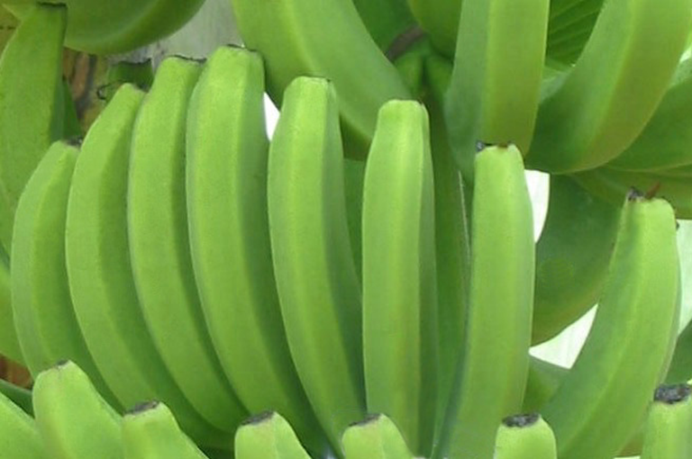
Slight | With 1 to 5 oviposition punctures in majority of the fingers | 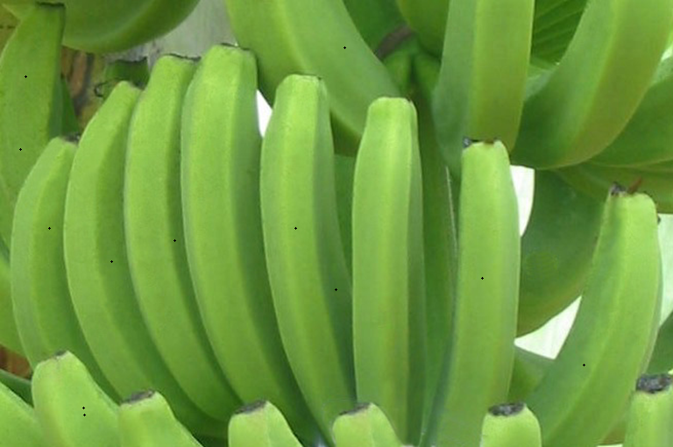
Moderate | With 6 to 10 oviposition punctures in majority of the fingers | 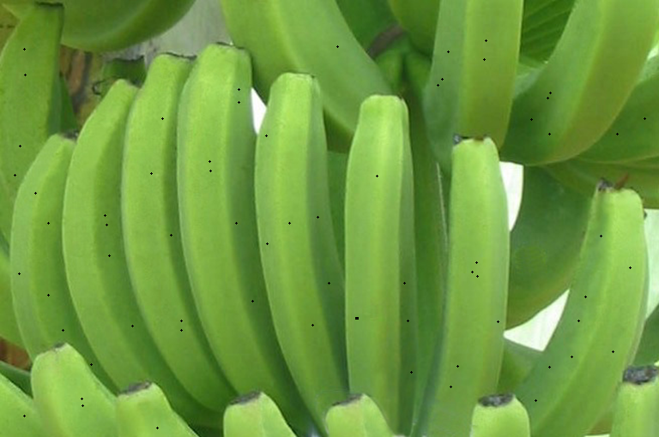
Severe | With more than 10 oviposition punctures in majority of the fingers | 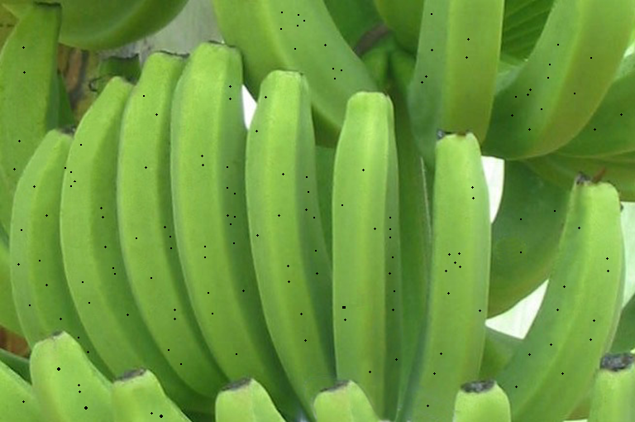

Table 2. Guide in determining the degree of water soaked damage caused by feeding of the Flower Thrips in ‘Cavendish’ banana
Degree of Damage | Water Soak Damage Description | Guide Photos
Clean | No water soak lesion | 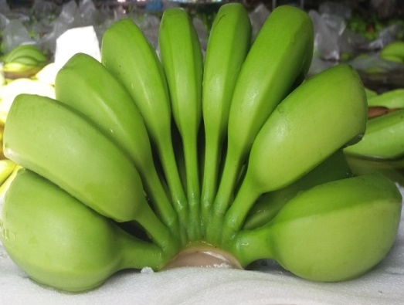
Slight | With water soak lesions from the crown to the neck or up to 1.5 cm. from the neck in majority of the fingers | 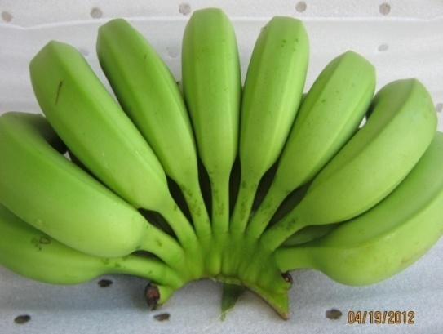
Moderate | With water soak lesions more than 1.5 cm. from the base of the neck in majority of the fingers | 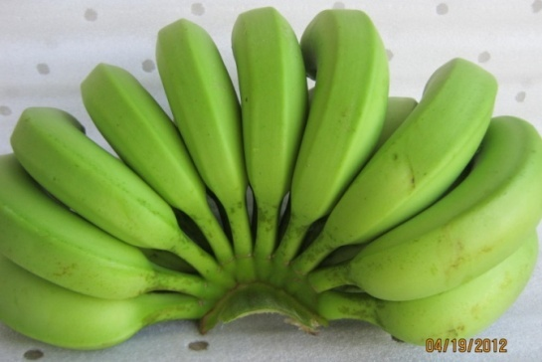
Severe | With water soak lesions throughout the ridges of the entire length in majority of the fingers | 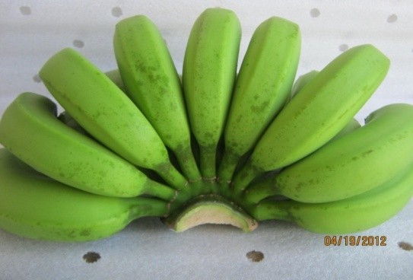

Table 3. Guide in determining the degree of brown scab damage caused by the feeding of Flower Thrips in ‘Cavendish’ banana
Degree of Damage | Brown Scab Damage Description | Guide Photos
Clean | No brown scab lesion | 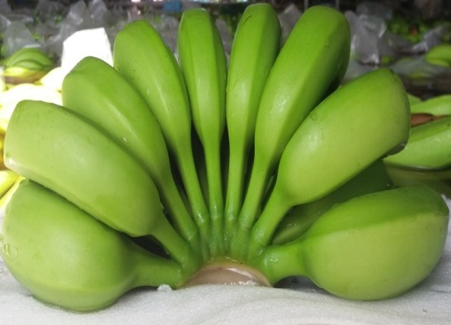
Slight | With brown scab lesions from the crown to the neck or up to 1.5 cm. from the neck in majority of the fingers | 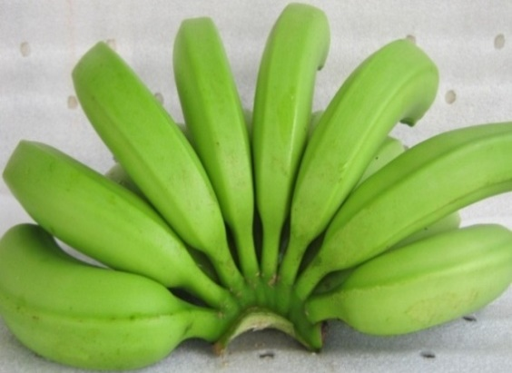
Moderate | With brown scab lesions more than 1.5 cm. from the base of the neck in majority of the fingers | 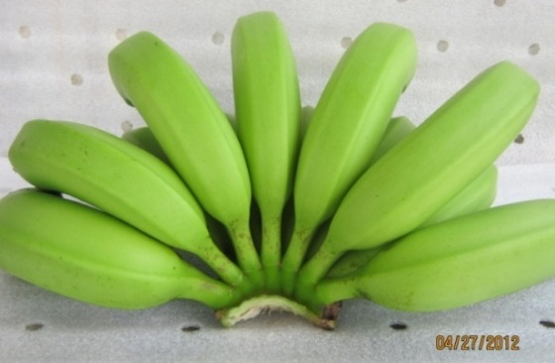
Severe | With brown scab lesions throughout the ridges of the entire length in majority of the fingers | 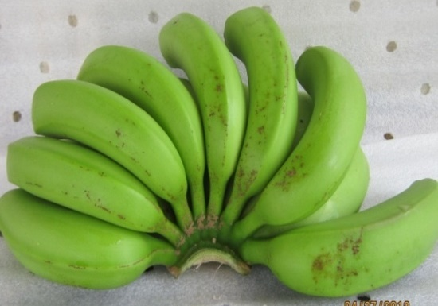

Experimental Design and Analysis

The study was laid out in a Randomized Complete Block Design (RCBD) having six (6) treatments with twelve (12) replicates per treatment. Data were analyzed using Analysis of Variance (ANOVA) followed by Unequal HSD and DMRT to look into the treatment and replicate effects. Corrected mortality was computed using Sun-Shepard’s formula.

RESULTS

Percent Thrips Mortality
Result showed that all concentrations of Matrine at 0.5, 1.0 and 1.5 mL/L of water tested were statistically comparable to commercial insecticide Abamectin 1.8SL at 4.0 mL/L of water in managing the thrips population on ‘Cavendish’ banana after three days from bud injection (Table 4). Although Matrine at 1.0 mL/L of water obtained the highest percent mortality with almost 10% compared to the Abamectin at 4.0 mL/L of water (commercial insecticide).
Table 4. Mean percent thrips mortality after 3 days from bud injection of different rates of Matrine
Treatments | % Thrips Mortality^{_1} |  | % Corrected Mortality^{_1}
Matrine at 0.5 mL/L of water |  | 46.08 ª | 51.19ª
Matrine at 1.0mL/L of water |  | 56.09 ª | 60.25 ª
Matrine at 1.5 mL/L of water |  | 49.70 ª | 54.47 ª
Abamectin 1.8SL at 4.0 mL/L of water |  | 46.03 ª | 51.15 ª
Water Only |  | 26.92 ^{b} | 33.85 ^{b}
No Injection |  | 10.47 ^{c} | 18.96 ^{c}
CV= |  | 15.73
^{1_}Means in column followed by common letter are not significantly different at 5% DMRT.

Thrips Damage
In terms of thrips oviposition damage, result showed that there was no statistical difference was noted among treatments. Among the treated buds, fruits from buds applied with Matrine at 1.5 mL/L obtained the highest mean percent of fruit with slight thrips oviposition damage and had the least mean percent of fruits with severe oviposition damage recovered (Table 5). While the highest percent of fruits which were severely damaged by the insect’s oviposition were treated with Abamectin 1.8SL at 4.0 mL/L of water and like the rest of the treatments almost no banana hands recovered to be free from oviposition marks (Table 6).

Table 5. Mean percent of fruits with thrips oviposition marks caused by banana flower thrips on 'Cavendish' 8-weeks
after bagging as affected by the application of different rates of Matrine
Treatments | Degree of Damage^{_1}
 | Clean⁻² |  | Slight |  |  | Moderate⁻² |  |  |  |  | Severe⁻²
Matrine at 0.5 mL/L of water | 0.00 ª |  |  | 90.99 ª |  |  | 0.00 ª |  |  | 9.01 ª
Matrine at 1.0mL/L of water | 0.00 ª |  |  | 90.80 ª |  |  | 0.00 ª |  |  | 9.20 ª
Matrine at 1.5 mL/L of water | 0.00 ª |  |  | 95.96 ª |  |  | 0.00 ª |  |  | 4.04 ª
Abamectin 1.8SL at 4.0 mL/L of water | 0.95 ª |  |  | 85.94 ª |  |  | 1.27 ª |  |  | 11.84 ª
Water Only | 0.00 ª |  |  | 89.84 ª |  |  | 0.92 ª |  |  | 9.24 ª
No Injection | 0.00 ª |  |  | 95.98 ª |  |  | 0.00 ª |  |  | 4.02 ª
CV= | 7.97 |  | 12.34 |  |  | 5.71 |  |  | 1.47
^{1_}Means in column followed by common letter are not significantly different at 5% Unequal N HSD Test.
^{2_} Values were transformed using Arc Sine transformation prior to One-way ANOVA followed by Unequal N HSD Test α=0.05

Class A Fruit Recovery

At harvest, banana hands were classified based on the standard quality set by the market. In Table 7 the result for the percent Class A fruits obtained after treatment application is presented. Among treatments, Matrine at 0.5 mL/L and Matrine at 1.0 mL/L gave superior results obtaining the highest Class A fruits at 97.05% and 98.31%, respectively. These results were comparable to commercial insecticide Abamectin 1.8SL at 4.0 mL/L of water and Matrine at 1.5 mL/L having 95.86% and 95.87% Class A fruits recovered, respectively.

Table 6. Mean percent of fruits with brown scab/water soak caused by banana flower thrips on 'Cavendish' 8-weeks after bagging as affected by the application of different rates of Matrine, TADECO, Bo. A. O. Floirendo, Panabo City
Treatments | Degree of Damage^{_1}
 | Clean^{_2} |  | Slight | Moderate^{_2} | Severe^{_2}
Matrine at 0.5 mL/L of water | 17.64 ª |  | 79.41 ª | 0.00 ª | 2.95 ª
Matrine at 1.0mL/L of water | 15.02 ^{ab} |  | 83.29 ª | 0.00 ª | 1.69 ª
Matrine at 1.5 mL/L of water | 11.24 ^{ab} |  | 81.58 ª | 0.95 ª | 6.23 ª
Abamectin 1.8SL at 4.0 mL/L of water | 26.42 ª |  | 69.45 ª | 0.00 ª | 4.13 ª
Water Only | 7.38 ^{b} |  | 77.81 ª | 3.05 ª | 11.75 ^{ab}
No Injection | 7.08 ^{b} |  | 71.99 ª | 0.00 ª | 20.12 ^{ab}
CV= | 1.34 |  | 23.15 | 4.10 | 1.65
^{1_} Means in column followed by common letter are not significantly different at 5% Unequal N HSD Test.
^{2_}Values were transformed using Arc Sine transformation prior to One-way ANOVA followed by Unequal N HSD Test α=0.05

Table 7. Mean percent of Class A fruits assessed on 8-Week Old Fruits as affected by the application of
different rates of Matrine, Bo. A. O. Floirendo, Panabo City
Treatment | Class A Fruits
Matrine at 0.5 mL/L of water | 97.05 ª
Matrine at 1.0mL/L of water | 98.31 ª
Matrine at 1.5 mL/L of water | 95.86 ^{ab}
Abamectin 1.8SL at 4.0 mL/L of water | 95.87 ^{ab}
Water Only | 88.85 ^{ab}
No Injection | 81.44 ^{b}
CV= | 12.87
^{1_} Means in column followed by common letter are not significantly different at 5% Unequal N HSD Test.

Banana Fruit Disease
No incidence of fruit spot and finger rot diseases were recorded in all experimental fruits. In addition, no incidence of moquillo noted in fruits applied with all rates of Matrine and fruits with no injection but incidence of the disease was observed in fruits applied with commercial insecticide Abamectin and to fruits applied with water only (Table 8).

Table 8. Fruit diseases of 'Cavendish' banana (8-WAB) injected with different rates of Matrine,
TADECO, Bo. A. O. Floirendo, Panabo City
Treatments |  | Banana Fruit Diseases
 |  | Moquillo | Fruit Spot | Finger Rot
Matrine at 0.5 mL/L of water | - |  | - | -
Matrine at 1.0mL/L of water | - |  | - | -
Matrine at 1.5 mL/L of water | - |  | - | -
Abamectin 1.8SL at 4.0 mL/L of water | + |  | - | -
Water Only | + |  | - | -
No Injection | - |  | - | -
Note: (-) negative signs indicate the absence of the banana disease and (+) positive signs indicate the presence of banana diseases.

Other Insect Pest
Scale insect was almost observed in all treatments except on fruits treated with Matrine at 1.0 mL/L of water. However, mealybug was only recorded on fruits applied with Matrine at 1.5 mL/L of water (Table 9).

Table 9. Other insect pest of 'Cavendish' banana (8-WAB) injected with different rates of Matrine,
TADECO, Bo. A. O. Floirendo, Panabo City
Treatments |  | Other Insect Pest
Matrine at 0.5 mL/L of water | Scale Insect |  | -
Matrine at 1.0mL/L of water |  | - | -
Matrine at 1.5 mL/L of water |  | Scale Insect | Mealybug
Abamectin at 4.0 mL/L of water |  | Scale Insect | -
Water Only |  | Scale Insect | -
No Injection |  | Scale Insect | -

DISCUSSION
The results obtained had demonstrated the insecticidal and anti-feedant action of Matrine against banana flower thrips. In the greenhouse study of Kim et al (2013) shows rather high percentage of mortality against insect pests when Matrine is applied in combination with other products. The combinations of Matrine with Bacillus thuriengensis at 0.2% and Matrine with Neem and B. thuriengensis at 0.1 and 0.2% gave 100% control value against larvae of leaf beetle (Phaedon brassicae) at three (3) days after treatment application. While, at 0.05% combinations of Matrine with Neem and B. thuriengensis, Matrine with B. thuriengensis at 0.5% and Matrine 0.1% alone also found good control against larvae of diamondback moth (Plutella xylostella) having 94%, 90% and 88% control values, respectively. This suggests that in order to achieve higher mortality rates of banana thrips, Matrine must be applied in combination with other products with potential insecticidal properties.
In addition, laboratory and field studies on Matrine-based biopesticide against four pest species of agricultural importance by Zanardi et al (2015) showed acaricidal and insecticidal action, in both cases depending on the target arthropod species. In general, the susceptibility of arthropods to the formulation followed the order P. citri > S. zeamais = S. frugiperda > D. citri. Considering the comparison of the mean lethal concentrations estimated, the product was 10 – 100 times more active against P. citri than against the remaining species of pest insects studied, reinforcing the biopesticides potent acaricidal action.
Cockfield et al (2007), in his findings on the timing of western thrips oviposition suggested that the surviving and emerging of new adults after the treatment application will lay eggs in the developing fruit. Newly emerged adults would have to recolonize the fruit to be responsible for the damage since efficacy of insecticides being applied became lesser in due time. Following the hypothesis of Cockfield, result suggests that studies on how to prolong the efficacy of Matrine must be explore to control the surviving insects and its offsprings. It was also observed that the fingers of the lower hands, which are the youngest on the bunch, are most severely attacked as successive layers of bracts peel away making younger hands become accessible for the thrips to deposit their egg (The Banana Board, 2011).
On the other hand, result on the brown scab and water soak damage showed that commercial insecticide Abamectin 1.8SL at 4.0 mL/L of water and Matrine at 0.5 mL/L of water gave superior result obtaining the highest clean fruits recovered with 26.42% and 17.64%, respectively. These results were statistically comparable to Matrine at 1.0 mL/L and 1.5 mL/L of water having 15.02 and 11.24 % clean fruits recovered, respectively (Table 6).
Brown scab and water soak damage were the results of thrips feeding in the fruit. The higher recovery of clean fruits on bunches injected with Matrine and Abamectin was maybe due to their anti-feedant and repellant property against banana flower thrips. According to Korea Bio Co. Ltd. (2014) that aside from mortality, Matrine also causes a significant decrease in the activity of the carbohydrate hydrolyzing enzymes activity wherein digestive system fails to function resulting to loss of appetite. It also contains natural saponins and complex secondary metabolites that act as an anti-feedant and repellant.
The reduction on flower thrips feeding damages like water soak and corky scab on Matrine treated bunches that resulted to high class A acceptable bunches corroborates the anti- feeding mode of action of Matrine. Loss of flower thrips appetite is due to the significant decrease in the action of the carbohydrate hydrolyzing enzymes activity wherein digestive system fails to function. In addition to anti-feeding property, quinolozidine alkaloids which are known as a bioactive material against pathogenic fungi, bacteria, and nematodes is also found in Matrine (Zeng and Lin, 1998; Mao and Henderson, 2007). This may contribute to the overall appearance of the banana.
Banana plantations spray fungicide and bactericide to the bunch when at least two hands already opened. Bunch spray solution is applied three (3) to four (4) times before bagging the bunch for the management of fruit diseases such as moquillo, fruit spot and finger rot. Absence of fruit spot and finger rot were maybe due to effective bunch spray control done during the trial period.
However, to validate the efficacy of Matrine against banana fruit diseases it is suggested to conduct follow-up study by using Matrine product as fungicide and bactericide in bunch spray solution through bunch spray application.
The one-time application of Matrine through bud injection did not control scale insect and mealybug which appeared during bagging stage. Generally, botanical extracts have low residual effect. Irulandi et al. (2008) verified the reduction in the insecticidal activity of botanical extracts against the coffee borer beetle, Hypothenemus hampei (Ferrari) (Coleoptera: Scolytidae) when comparing the extract's efficacy under laboratory and field conditions. In addition, Xiang et al. (2012) demonstrated that the half-life of alkaloid Matrine is seven days, that is, Matrine degrades relatively quickly in the environment. In this study, bud injection was done only once thus, for future study using Matrine, in order to determine its effect on scale insect and mealybug a follow-up application at 7-day interval must be conducted.

CONCLUSION
Based on the % mortality rate, water soaked and corky scab damage due to feeding, oviposition damage, and percent Class A fruit, Matrine at 0.5, 1.0 and 1.5 ml/Liter of water were as effective as the commercial insecticide in controlling Flower Thrips on “Cavendish” banana and the product did not cause any phytotoxicity/chemical injury in banana fruits applied with Matrine through bud injection. And it can be used as alternative treatments for thrips to the commercial insecticide, Abamectin.

ACKNOWLEDGEMENT
Aktiv Multi Trading Corporation Philippines Incorporated and Entomology Research Division of Tagum Agricultural Development Corporation (TADECO)

REFERENCES
COCKFIELD, S.D., BEERS, E. H., HORTON, D.R. AND MILICZKY, E. 2007. Timing of Oviposition by Western Thrips (Thysanoptera Thripdea) in Apple fruit. Journal of the Entomological Society of British Columbia pp. 45- 53.
IRULANDI, S., RAJENDRAN, R., SAMUEL, S.D., RAVIKUMAR, A., VINODKUMAR, P.K., SREEDHARAN, K., 2008. Effect of botanical insecticides on coffee berry borer, Hypothenemus hampei (Ferrari) (Coleoptera: Scolytidae). Journal of Biopesticides 1(1):70-73
KIM, M.J., Shim, C.K., Kim, K.M., Jee, H.J., Yin, J.C., Hong, H.J., Park, J.H. and Han, E.J. 2013. Insecticidal Effect of Organic Materials of Bt, Neem and Matrine Alone and Its Mixtures Against Major Insect Pest of Organic Chinese Cabbage. The Korean Journal of Pesticide Science, 1(3):213-219
KOREA BIO CO., LTD. 2014. Aktrine 4.6SL Brochure 288-1, Mangwol-ri,Jungnam-myun, Hwaseong-si, Gyeonggi-do, Korea.
LIM, S., LEE, J., KIM, J. CHOI, G. CHO, N. AND PARK, B. 2014. Determination of Dimethyl Disulfide, Diallyl Disulfide, and Diallyl Trisulfide in Biopesticides Containing Allium sativum Extract by Gas Chromatography. Korean Journal of Environmental Agriculture, 33(4):237-243
MAO, L. AND HENDERSON, G. 2007. Antifeedant Activity and Acute Residual Toxicity of Alkaloids from Sophora flavescens (Leguminosae) against Formosan Subterranean Termites (Isoptera: Rhinotermitidae). Journal of Economic Entomology, 100: 866-870.
OSTMARK, H.E. 1974. Economic insect pests of bananas. Annual Review of Entomology, 19:161-76
SIVAKUMAR, C.B. AND MOHANASUNDARAM, M. 1971. The banana rust thrips in Tamil Nadu, India. Madras Agricultural Journal (58): 363-366
SWAINE, G. AND R.J. CORCORAN. 1970. Banana flower thrips and its relationship to corky scab damage of Cavendish bananas in south-east Queensland. Queensland Journal of Agriculture and Animal Science 32(1):79–89.

THE BANANA BOARD, http://thebananaboard.org/index.php/features/disease/thrips. (Accessed 28 January 2015).
XIANG, Z., SHANG, S., CAI, K., GENG, Z., CHEN, X., 2012. Determination and decline study of matrine residue in tobacco by gas chromatography-nitrogen chemiluminessence detector. Chinese Journal of Pesticide Science 14:115-121.
ZANARDI, O.Z., RIBEIRO, L.P., YAMAMOTO, P.T AND VENDRAMIN, J.D. 2015. Bioactivity of a matrine-based biopesticide for four pest-specie of agricultural importance. Crop Protection 67: 160-167.

ZENG, X.N. & LIN J.T. 1998. Damage of Thrips hawaiiensis (Morgan) to banana and its control. Plant Protection 24(6): 15–17

